DAY 14 - C/C++ PROGRAMMING - HARSHINIE M

/*
Purpose : Fill an array of 100 elements using 5 threads
Question: Create a global array of 100 elements and use 5 threads where
each thread fills 20 elements of the array.
Author : Harshinie M
Date : 09/01/2026
*/

#include <iostream>
#include <thread>
#include <vector>

using namespace std;

// Global array of 100 elements
int arr[100];

// Thread function to fill part of the array
void fillArray(int startIndex, int count)
{
for (int i = startIndex; i < startIndex + count; i++)
{
arr[i] = 100 + i; // Assigning value for identification
}
}

int main()
{
const int numThreads = 5;
const int elementsPerThread = 20;

vector<thread> threads;

// Creating 5 threads
for (int i = 0; i < numThreads; i++)
{
threads.emplace_back(
fillArray,
i * elementsPerThread, // Starting index
elementsPerThread // Number of elements
);
}

// Waiting for all threads to finish
for (auto &t : threads)
{
t.join();
}

cout << "Array: ";

// Displaying the array
for (int i = 0; i < 100; i++)
{
cout << arr[i] << " ";
}

cout << endl;

return 0;
}

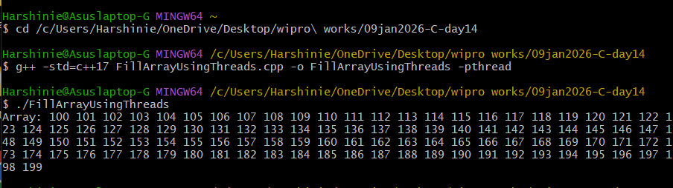

/*
Purpose : Fill an array of 100 elements using 5 threads
Question: Create a local static array of 100 elements inside main()
and use 5 threads where each thread fills 20 elements.
Author : Harshinie M
Date : 09/01/2026
*/

#include <iostream>
#include <thread>
#include <vector>

using namespace std;

// Thread function
void fillArray(int* arr, int startIndex, int count)
{
for (int i = startIndex; i < startIndex + count; i++)
{
arr[i] = 100 + i; // Assign values for identification
}
}

int main()
{
// Local static array (shared across threads)
static int arr[100];

const int numThreads = 5;
const int elementsPerThread = 20;

vector<thread> threads;

// Creating threads
for (int i = 0; i < numThreads; i++)
{
threads.emplace_back(
fillArray,
arr, // Pointer to static array
i * elementsPerThread, // Starting index
elementsPerThread // Number of elements
);
}

// Waiting for all threads to finish
for (auto &t : threads)
{
t.join();
}

cout << "Array: ";

// Display array contents
for (int i = 0; i < 100; i++)
{
cout << arr[i] << " ";
}

cout << endl;

return 0;
}

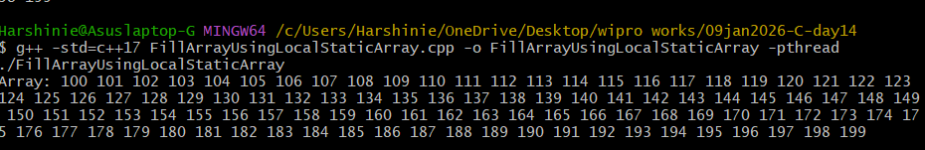

/*
Purpose : Fill an array of 100 elements using 5 threads
Question: Create a heap (dynamic) array of 100 elements and use 5 threads
where each thread fills 20 elements of the array.
Author : Harshinie M
Date : 09/01/2026
*/

#include <iostream>
#include <thread>
#include <vector>

using namespace std;

// Thread function
void fillArray(int* arr, int startIndex, int count)
{
for (int i = startIndex; i < startIndex + count; i++)
{
arr[i] = 100 + i; // Assign values for verification
}
}

int main()
{
// Heap array (shared across threads)
int *arr = new int[100];

const int numThreads = 5;
const int elementsPerThread = 20;

vector<thread> threads;

// Creating threads
for (int i = 0; i < numThreads; i++)
{
threads.emplace_back(
fillArray,
arr, // Pointer to heap array
i * elementsPerThread, // Starting index
elementsPerThread // Number of elements
);
}

// Waiting for all threads to finish
for (auto &t : threads)
{
t.join();
}

cout << "Array: ";

// Display array contents
for (int i = 0; i < 100; i++)
{
cout << arr[i] << " ";
}

cout << endl;

// Free dynamically allocated memory
delete [] arr;

return 0;
}

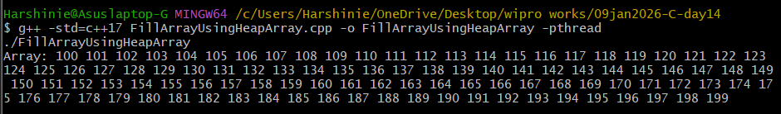

/*
Purpose : Fill an array of 100 elements using 5 threads
Question: Create a vector of 100 elements and use 5 threads where
each thread fills 20 elements of the vector.
Author : Harshinie M
Date : 09/01/2026
*/

#include <iostream>
#include <thread>
#include <vector>

using namespace std;

// Thread function
void fillArray(vector<int> &arr, int startIndex, int count)
{
for (int i = startIndex; i < startIndex + count; i++)
{
arr[i] = 100 + i; // Assign values for verification
}
}

int main()
{
// Vector (dynamic array managed by STL)
vector<int> vArr(100);

const int numThreads = 5;
const int elementsPerThread = 20;

vector<thread> threads;

// Creating threads
for (int i = 0; i < numThreads; i++)
{
threads.emplace_back(
fillArray,
ref(vArr), // Pass vector by reference
i * elementsPerThread, // Starting index
elementsPerThread // Number of elements
);
}

// Waiting for all threads to finish
for (auto &t : threads)
{
t.join();
}

cout << "Array: ";

// Display vector contents
for (int i : vArr)
{
cout << i << " ";
}

cout << endl;

return 0;
}

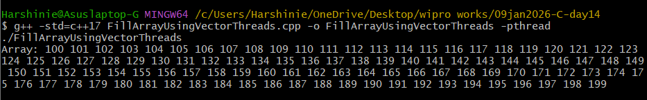

/*
Purpose : Fill an array of 100 elements using 5 threads
Question: Create a dynamic array using smart pointer (unique_ptr)
and use 5 threads where each thread fills 20 elements.
Author : Harshinie M
Date : 09/01/2026
*/

#include <iostream>
#include <thread>
#include <vector>
#include <memory> // Required for unique_ptr

using namespace std;

// Thread function
void fillArray(int* arr, int startIndex, int count)
{
for (int i = startIndex; i < startIndex + count; i++)
{
arr[i] = 100 + i; // Assign values for verification
}
}

int main()
{
// Smart pointer (unique_ptr) managing a dynamic array
auto arr = make_unique<int[]>(100);

const int numThreads = 5;
const int elementsPerThread = 20;

vector<thread> threads;

// Creating threads
for (int i = 0; i < numThreads; i++)
{
threads.emplace_back(
fillArray,
arr.get(), // Get raw pointer from unique_ptr
i * elementsPerThread, // Starting index
elementsPerThread // Number of elements
);
}

// Waiting for all threads to finish
for (auto &t : threads)
{
t.join();
}

cout << "Array: ";

// Display array contents
for (int i = 0; i < 100; i++)
{
cout << arr[i] << " ";
}

cout << endl;

// No delete required (unique_ptr cleans up automatically)

return 0;
}

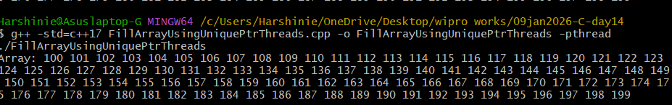

/*
Purpose : Demonstrate synchronization using mutex
Question: Create multiple threads to update a global variable safely
using mutex to avoid race condition.
Author : Harshinie M
Date : 09/01/2026
*/

#include <iostream>
#include <thread>
#include <mutex>

using namespace std;

// Global variable shared among threads
int globVar = 0;

// Mutex for synchronization
mutex mVar;

// Thread function
void Update()
{
// Acquire lock on mutex
unique_lock<mutex> lock(mVar);

for (int cnt = 0; cnt < 100000; cnt++)
globVar++;

// Explicitly release lock
lock.unlock();
}

int main()
{
// Create three threads
thread t1(Update);
thread t2(Update);
thread t3(Update);

// Wait for threads to finish
t1.join();
t2.join();
t3.join();

// Display final value
cout << "global var: " << globVar << endl;

return 0;
}

/*
Purpose : Demonstrate thread synchronization using condition_variable
Question: Create a thread that waits for a notification using
condition_variable and proceeds only after receiving it.
Author : Harshinie M
Date : 09/01/2026
*/

#include <iostream>
#include <thread>
#include <mutex>
#include <chrono>
#include <condition_variable>

using namespace std;

// Mutex and condition variable
mutex mVar;
condition_variable cVar;

// Shared condition flag
bool ready = false;

// Thread function
void funOne()
{
unique_lock<mutex> lock(mVar);

// Wait until 'ready' becomes true
cVar.wait(lock, [] { return ready; });

cout << "Received Notification.. Proceeding now " << ready << endl;
}

int main()
{
// Create thread
thread t1(funOne);

// Simulate some work in main thread
this_thread::sleep_for(chrono::seconds(2));

{
// Lock mutex and update condition
lock_guard<mutex> lock(mVar);
ready = true;
}

// Notify waiting thread
cVar.notify_one();

// Wait for thread to finish
t1.join();

return 0;
}

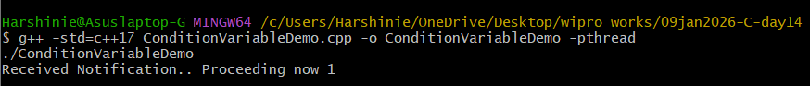

/*
Purpose : Demonstrate inter-thread communication using promise and future
Question: Create a thread that calculates the sum of numbers and sends
the result to the main thread using promise and future.
Author : Harshinie M
Date : 09/01/2026
*/

#include <iostream>
#include <thread>
#include <chrono>
#include <future>

using namespace std;

// Thread function
void calculateSum(promise<int> prom)
{
int sum = 0;

for (int i = 1; i <= 10; i++)
{
this_thread::sleep_for(chrono::seconds(1));
sum += i;
}

// Set the result in promise
prom.set_value(sum);
}

int main()
{
// Create promise object
promise<int> pObj;

// Get future from promise
future<int> fObj = pObj.get_future();

// Create thread and transfer ownership of promise
thread t1(calculateSum, move(pObj));

// Wait for result from future
int result = fObj.get();

cout << "Result : " << result << endl;

// Wait for thread to finish
t1.join();

return 0;
}

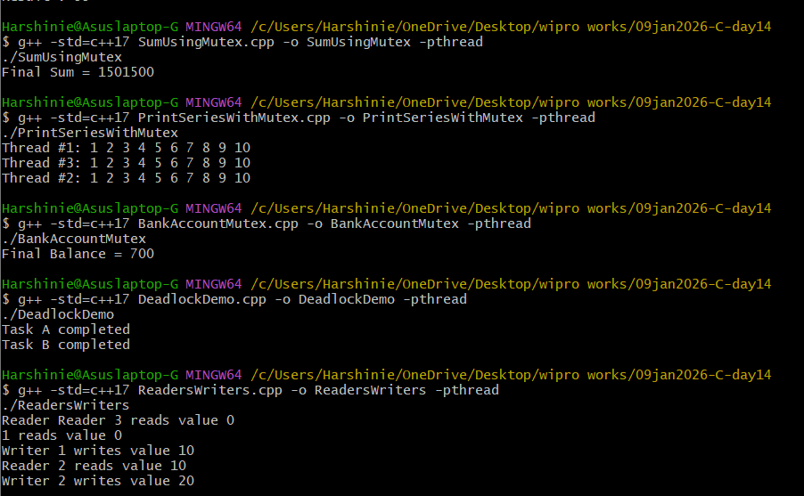

/*
Purpose : Demonstrate a simple thread pool implementation
Question: Create a thread pool that executes submitted tasks using
worker threads, mutex, and condition_variable.
Author : Harshinie M
Date : 09/01/2026
*/

#include <iostream>
#include <thread>
#include <vector>
#include <queue>
#include <mutex>
#include <condition_variable>
#include <functional>
#include <chrono>

using namespace std;

class SimpleThreadPool
{
vector<thread> workers; // Worker threads
queue<function<void()>> tasks; // Task queue

mutex mLock;
condition_variable cLock;
bool stop = false;

public:
// Constructor: creates worker threads
SimpleThreadPool(unsigned int num)
{
for (unsigned int i = 0; i < num; ++i)
{
workers.emplace_back([this] {
while (true)
{
function<void()> task;

{
unique_lock<mutex> lock(mLock);

// Wait until task is available or pool is stopped
cLock.wait(lock, [this] {
return stop || !tasks.empty();
});

if (stop && tasks.empty())
return;

task = move(tasks.front());
tasks.pop();
}

// Execute task outside the lock
task();
}
});
}
}

// Submit a task to the pool
void submit(function<void()> task)
{
{
lock_guard<mutex> lock(mLock);
tasks.push(task);
}
cLock.notify_one();
}

// Destructor: stops threads and joins them
~SimpleThreadPool()
{
{
lock_guard<mutex> lock(mLock);
stop = true;
}

cLock.notify_all();

for (auto &t : workers)
t.join();
}
};

int main()
{
// Create thread pool with 3 worker threads
SimpleThreadPool pool(3);

// Submit 6 tasks
for (int i = 0; i < 6; ++i)
{
pool.submit([i] {
cout << "Task " << i + 1
<< " executed by thread "
<< this_thread::get_id() << endl;

this_thread::sleep_for(chrono::seconds(1));
});
}

return 0;
}

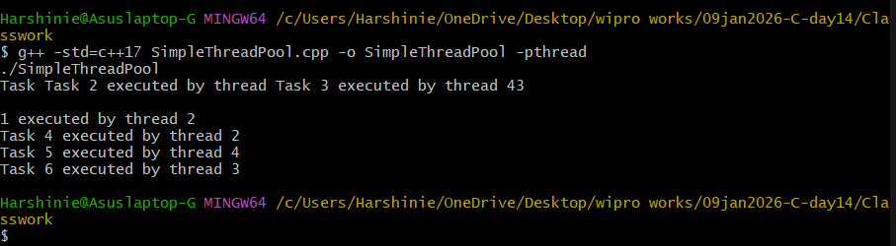

/*
Purpose : Demonstrate usage of std::function with functions and lambda
Question: Assign a normal function and a lambda expression to std::function
and invoke them.
Author : Harshinie M
Date : 09/01/2026
*/

#include <iostream>
#include <functional>

using namespace std;

// Normal function: Addition
int Add(int x, int y)
{
return x + y;
}

// Normal function: Subtraction
int Sub(int x, int y)
{
return x - y;
}

int main()
{
// std::function holding a normal function
function<int(int, int)> fObj = Add;

int res1 = fObj(100, 200);
cout << "Result using normal function (Add): " << res1 << endl;

// std::function holding a lambda expression
function<int(int, int)> fObj2 = [](int x, int y) {
return x + y;
};

int res2 = fObj2(10, 20);
cout << "Result using lambda function: " << res2 << endl;

return 0;
}

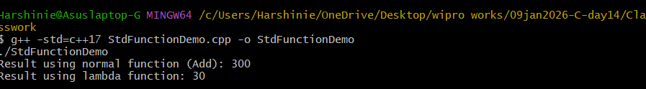

7th program - Assign
